|  |  |
| --- | --- |
| **Application:** | Shop Floor Scheduler |
| **Description:** | Shop Floor Scheduler |
| **Revision:** | V 1.0.12 |
| **Date:** | 28-07-2014 |
|  |  |

Table of Contents

1. 1.0.12 3

1.1. Button to copy Job 3

1.2. Import Job Activities 3

1.3. Reschedule Completed Job 3

1.4. Log Time via Job Edit screen 3

1.5. Auto Assign Activity To primary Artisan 3

1.6. To say artisan is Foreman 3

1.7. Allocate artisan to Foreman 3

1.8. Artisan to move activity to another artisan 3

1.9. Added Created User on activity record 3

1.10. Added quantity to Activity 3

1.11. Activities read-only when created via SQL trigger 3

1.12. Comments on Checklist 4

# 1.0.12

## Button to copy Job

Allows you to copy job and activities for the job

## Import Job Activities

Import activities from another job into current job

## Reschedule Completed Job

Completed jobs can now be rescheduled and run thru the entire process again

## Log Time via Job Edit screen

Time can now be logged on an activity by selecting it and clicking on log time. This will allow user to log time if system is down and comes back up again. When Completed is selected next activity must be selected.

## Auto Assign Activity To primary Artisan

When a new activity is added to a job and there is already a primary artisan allocated to the job it will assign that artisan to the activity on save.

## To say artisan is Foreman

Artisans can now be marked as being a foreman

## Allocate artisan to Foreman

Artisans can now be allocated to artisans that have been marked as foreman

## Artisan to move activity to another artisan

Artisan can move an activity to a different artisan in the activity control screen. This also gets logged under the activity if it was moved to a different artisan by another artisan.

## Added Created User on activity record

This allows to track if activity was created via SQL trigger or a user in scheduler.

## Added quantity to Activity

Total Estimate Duration equals quantity * estimated duration.

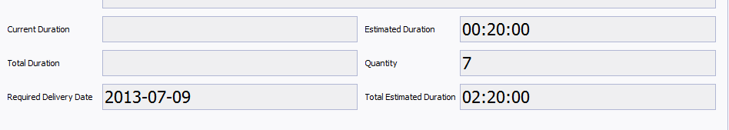

## Activities read-only when created via SQL trigger

Activities that are created via SQL trigger can’t be changed or be deleted. Only the Artisan can be changed.

## Comments on Checklist

On check list when Comment Enabled is checked a comment box will be available when checklist is completed.

